**Reversing an Array**

**1) Method 1 : By using two arrays**

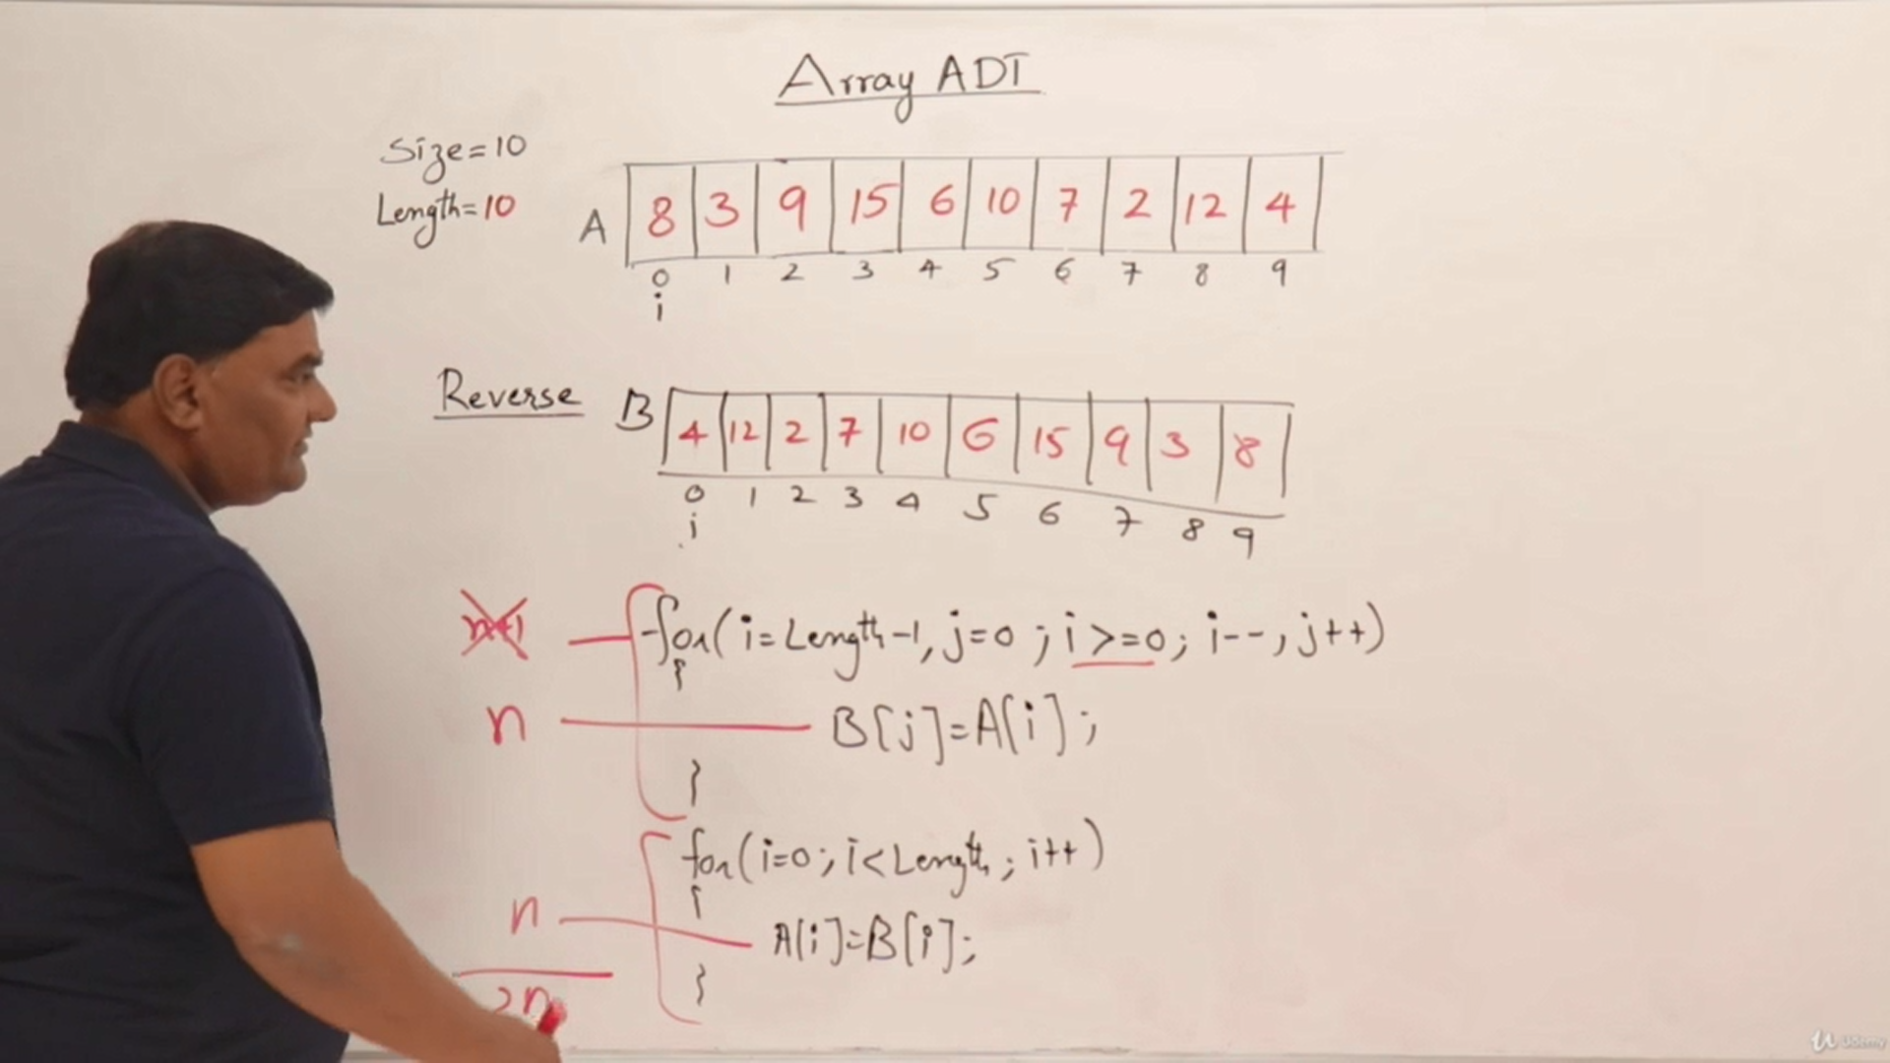

**2) Without using auxiliary array**

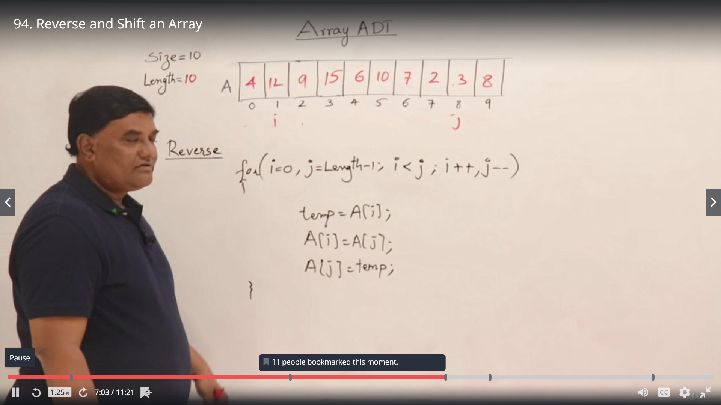

**Left Shifting the elements**

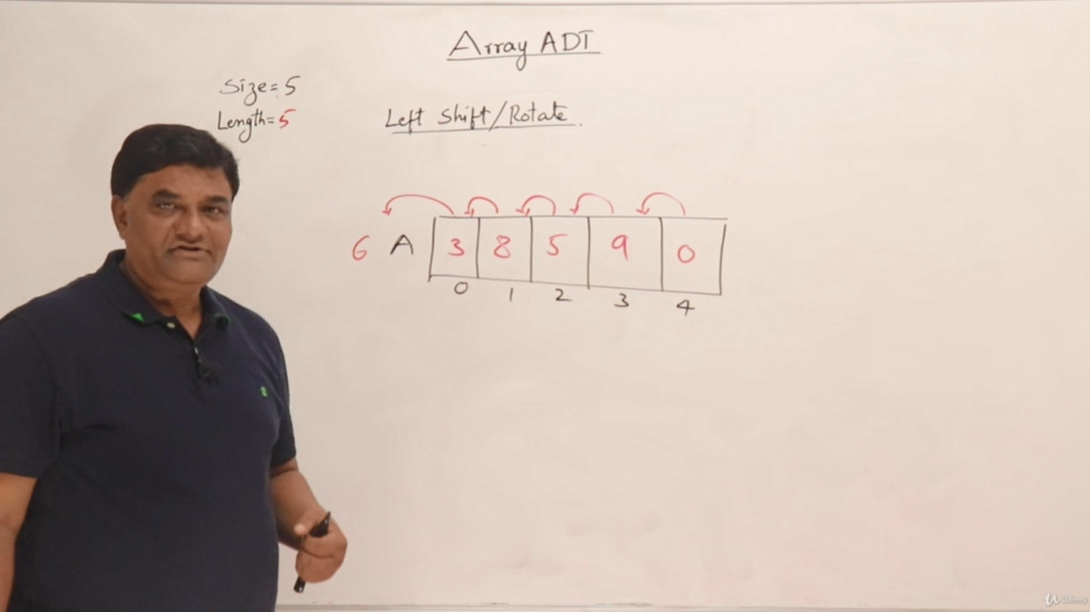

**6 is gone out of the array**

**Rotating the elements.** (i.e) Pushing the popped out element to the last

Pushing 6 to the last position

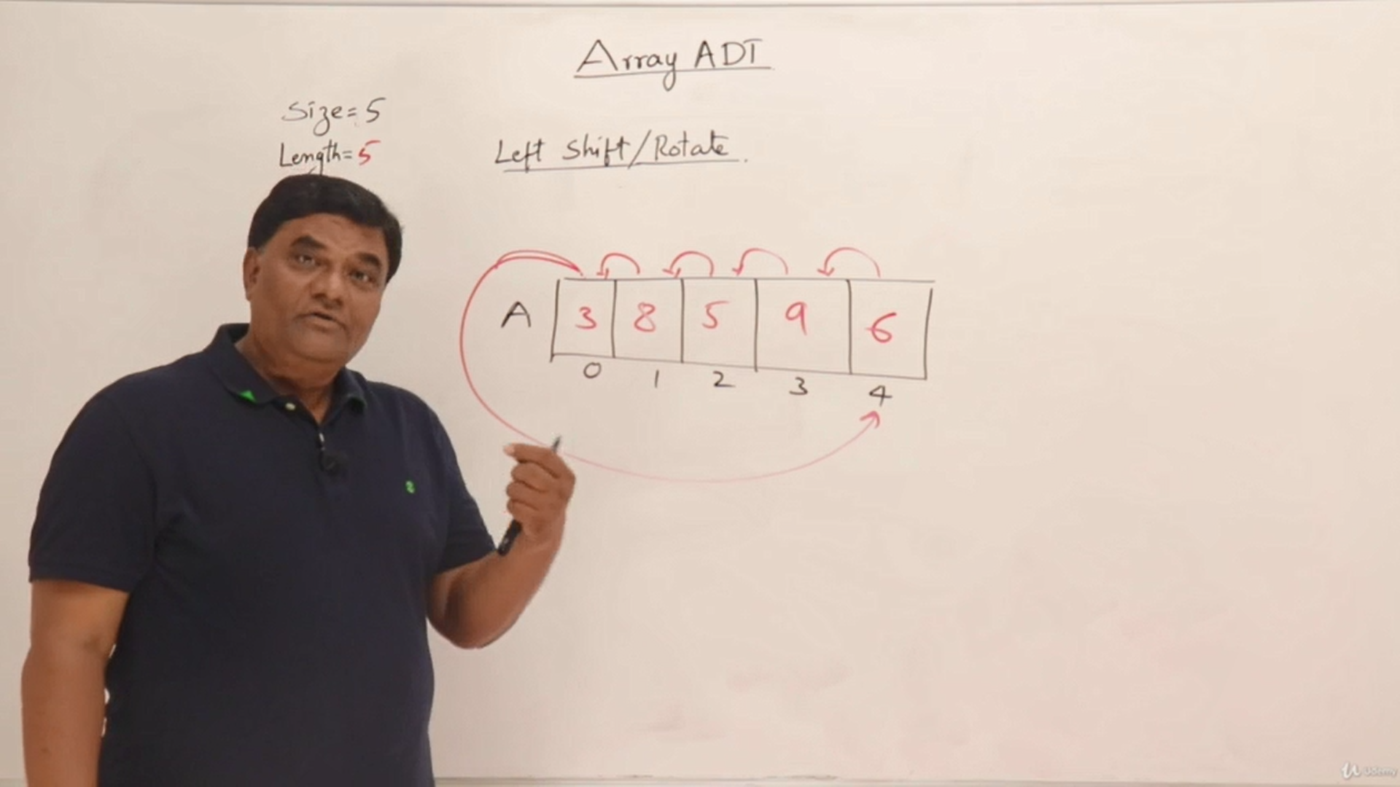

**Eg: LED Display**

